**MACHINE LEARNING MODEL DEPLOYMENT WITH IBM CLOUD WATSON STUDIO**

**NAME: POOJA.B**

**Aim:** To deploy a machine learning algorithm in Watson studio

# Requirements:

* Data Set for Project.
* IBM cloud account

# Outcome:

In this tutorial, you will explore the following services.

* Watson Studio service
* Cloud object Storage
* Machine learning instance
* Training the machine learning model with data set in Auto AI experiment
* IBM WATSON PLATFORM

# Activities:

* Create the Watson Studio.
* Adding the cloud object storage.
* Create Auto AI experiment.
* Training and Deploying the Auto AI Experiment.
* Creating the Web UI to visualize the data

# Task-1: Create the Watson Studio I

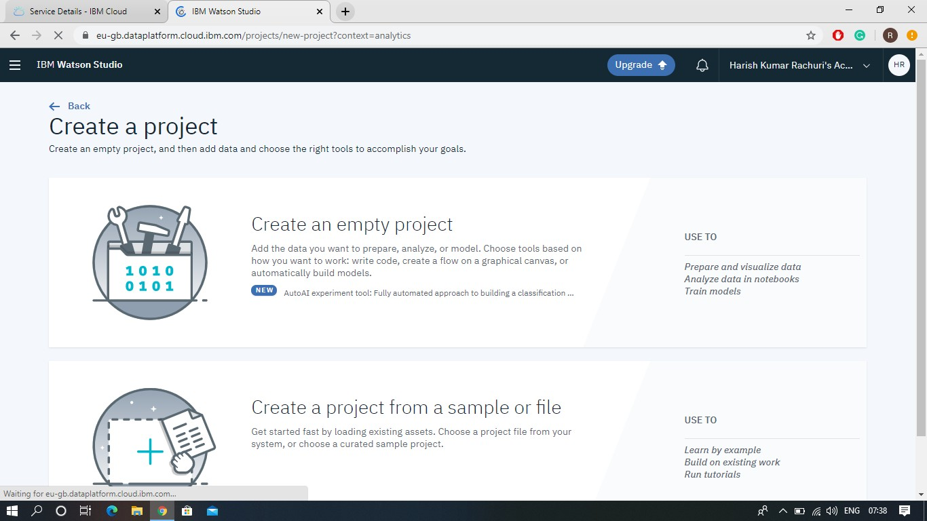

# Task 2: Adding the Object Storage to project

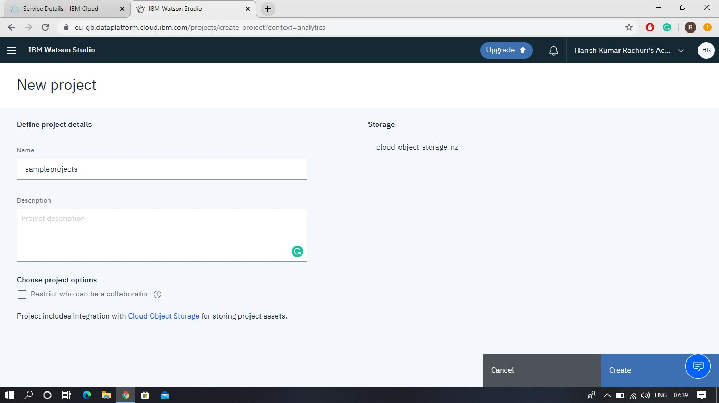

# Task-3: Creating an Auto AI Experimentt

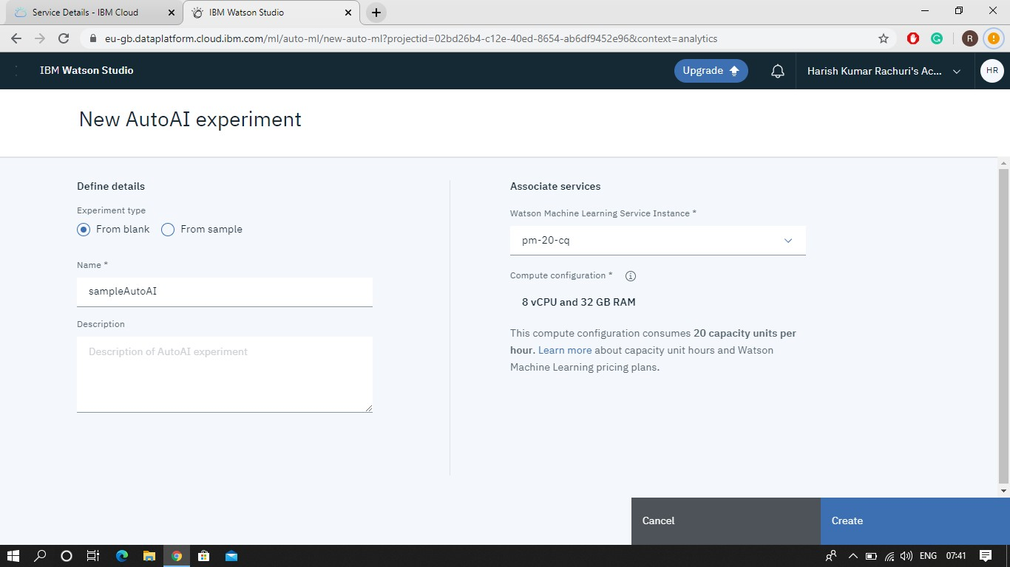

# Task 4: Training and Deploying the Auto AI Experiment.

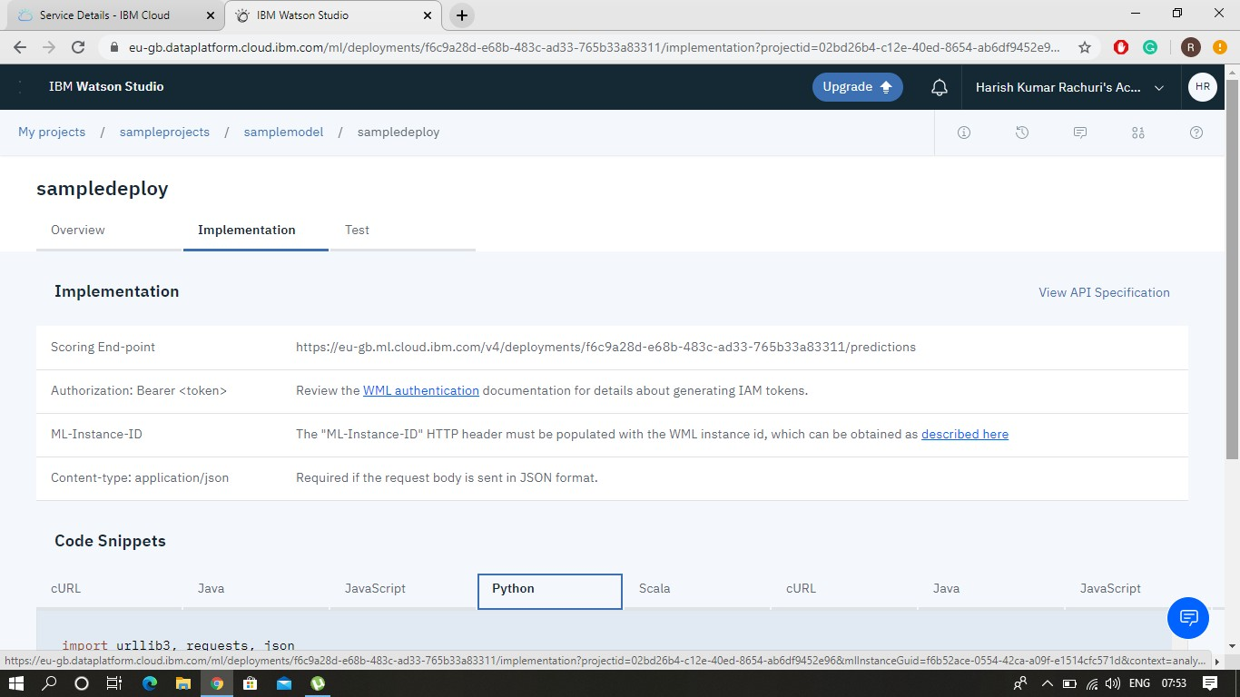

**Task 5: Creating the Web UI to visualize the data**

